Groote structure herkenen card, caroesel, navbar

Thomas more1.0

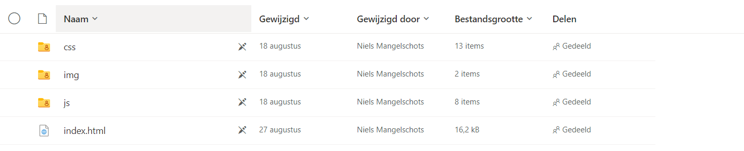

Ctrl + u

Googel maps -> delen -> een kaart insluiten -> maat eventueel aanpassen

Thomas more 2.0

Steek geen tijd in moeilijkere carrousel !!!!

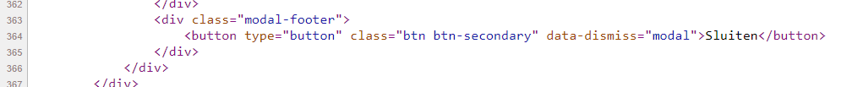

Card over heel het scherm = featured

Card height in bootstrap

<https://getbootstrap.com/docs/4.0/components/card/>

om dit te verkomen

